WOODBROOK ESTATES
NEIGHBORHOOD WATCH
PATROL MANUAL

Ver 2.4
November 2023

Lakeland Police Non-Emergency Number
863-834-6900

Office Normal Hours
863-682-1510

Office After Hours Emergency Number
844-285-2099

Neighborhood Watch Coordinator
503-984-2373

CONTENTS

SECTION
1................................... Mission
2................................... Patrol Cart
3................................... Patrol Procedures
4................................... Main and Secondary Gates
5................................... Clubhouse Lockup
6................................... Pools
7................................... Version Control

MISSION

The Neighborhood Watch Program is a volunteer group of individuals from the Woodbrook Estates community who are interested in keeping one another safe. Any resident, full time or part time is welcome and encouraged to participate by volunteering for a week of patrol and lock up activities. Training shifts will be provided to all new volunteers and follow-ups can be planned through Neighborhood Watch Coordinator.

Our nighttime patrols provide several important functions including:

- Assisting any resident in need of help. We live in a community whose residents are unfortunately growing older and more infirm each day, where the possibility of encountering someone who has collapsed, is lost, or needs medical attention in quite real.

- Providing a visual deterrent to outsiders.

- Securing the pool areas to prevent after hours use and to comply with Woodbrook pools hours of availability.

- Ensuring the main and secondary gates are closed and are functioning properly.

- Ensuring the storage area and associated buildings are secure.

- Checking and securing both clubhouses.

- Ensuring the rear perimeter fence gates are secure.

- Providing a general feeling of security to our residents.

- Question, observe and report any suspicious persons or activity in the park.

The above functions will be explained in detail in the following pages.

PATROL CART

The patrol cart is a 48V electric golf cart that is equipped with two amber flashing roof lights, flashlights, logbook, a park telephone directory, a map of the park, and the charging cord.

The Neighborhood Watch Coordinator will perform general and routine maintenance on the golf cart including air in the tires, flashlights, batteries, and keeping the logbook and manual updated.

The patrol week runs from Sunday night through Saturday night. The cart should be delivered to the Neighborhood Watch Coordinator for weekly maintenance on Sunday morning after the completion of the patrol week. The cart will then be delivered to the next volunteer on Sunday afternoon prepared for the next weeks use.

Volunteers will be responsible for keeping the cart charged. Per the dealer, the cart should only be charged when the battery level gets below 50%

Volunteers are asked to familiarize themselves with the cart, the manual, and the logbook on the day that you receive it to see if there are any notes that you may need to watch for while on patrol.

The cart is equipped with a cabin enclosure for protection from the elements.

Emergency and non-emergency phone numbers are posted on the windshield.

Volunteers are allowed to use the cart for personal use during their patrol week.

THE NEIGHBORHOOD WATCH CART IS NOT INTENDED FOR VISITING FAMILY MEMEBERS OR GUEST.

NO ONE UNDER THE AGE OF 21 IS ALLOWED TO DRIVE OR OTHERWISE OPERATE THE NEIGHBORHOOD WATCH CART

THE CART MUST NEVER LEAVE THE GROUNDS OF WOODBROOK ESTATES.

ABSOLUTELY NO FIREARMS OR WEAPONS ARE ALLOWED ON THE CART OR WHILE ON WATCH.

PATROL PROCEEDURES

IF YOU FEEL THAT YOU ARE IN DANGER AT ANY TIME DIAL 911 IMMEDIATELY

The nightly patrol should begin at approximately 10:00PM. Earlier starts on a limited basis can be allowed, but should NEVER begin earlier than 9:30PM, and residents are ALWAYS allowed access to the facilities until 10:00PM. The nightly patrol should take between 1 hour and 90 minutes to complete properly.

Item Number 1 of our mission statement is to assist any resident in need of help. Therefore, while on patrol the cart should be driven at a speed that allows the driver to easily peer between each house and into each driveway on both sides of the street as you go past. As pointed out in the Mission Statement, we live in a community whose residents are unfortunately growing older and more infirm each day, where the possibility of encountering someone who has collapsed, is lost, or needs medical attention in quite real.

Item 2 on our mission statement is to Provide a Visual Deterrent to Outsiders, this is best exhibited by clearly showing that the patrol is being observant. So please remember to drive slowly so that you can both observe and can be observed as well. If the hours of 10:00PM to 11:00PM are inconvenient, or driving slowly not of your liking, we appreciate your help but would kindly ask that you no longer volunteer as we currently have enough people to fill any vacant slots.

You may begin and end the patrol at any location you choose as long as the entire route and tasks are completed.

You are welcome to take one passenger with you if you wish, and we encourage all lady volunteers to do so for safety concerns.

Ensure that you have a cell phone, with a camera, with you always while on patrol. We encourage you to take a photo whenever it might be considered useful, and to forward it to the Neighborhood Watch Coordinator.

The Lakeland Emergency and Non-Emergency phone numbers are posted near the top of the windshield and should be programmed into your phone.

The Neighborhood Watch Coordinator will ensure that the flashlights and batteries are operational and will provide spare batteries each week.

At least one pass down each street of the park should be made, and further patrol passes are welcome.
The Flashing Roof Light should be activated during the entire patrol. The lights can and should be turned off while stopped at the clubhouses and while speaking to residents as it makes conversation difficult.

While on patrol, observe each home as you pass. Watch for elderly people who may have fallen around doors and driveways, suspicious people, or activity in the area. Check for open house doors, shed doors, broken windows etc., especially at homes that are unoccupied at the time. If any open or damaged doors are noted, call the Neighborhood Watch Coordinator, and note it in the logbook. If it appears that the home has been entered illegally, notify the Lakeland Police Department and the Neighborhood Watch Coordinator, but DO NOT ENTER THE BUILDING. If a crime is currently in progress DIAL 911.

Shining the flashlight around houses and at the doors of UNOCCUPIED houses is recommended. Please do not shine the flashlight at or in any windows, especially when it’s clear that residents are home.

Look for any valuable or personal property left unsecured and note it in the logbook with the item and the Lot Number, and if possible, notify the Neighborhood Watch Coordinator the next day.

Shine the flashlight and observe as you pass any green space areas such as the lawns around the South Clubhouse, the horseshoe and shuffleboard areas, and the green space around the pond. Do the same for the green space around the North Clubhouse, shuffleboard and bocci courts and across the street at the Alligator Park.

Check the two gates of the RV storage area are chained, the padlocks are locked, and ensure that no access can be gain through them.
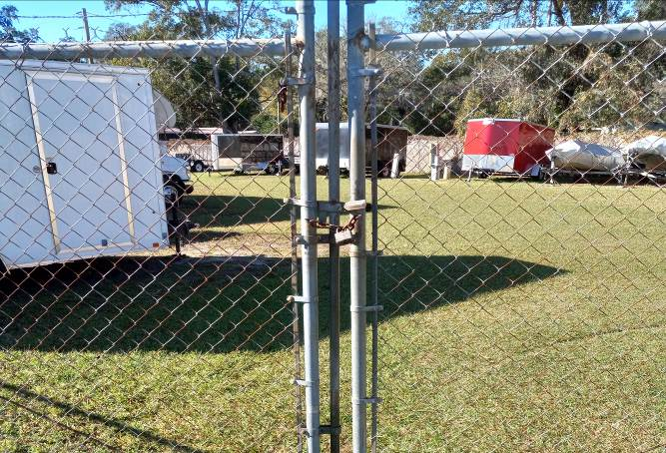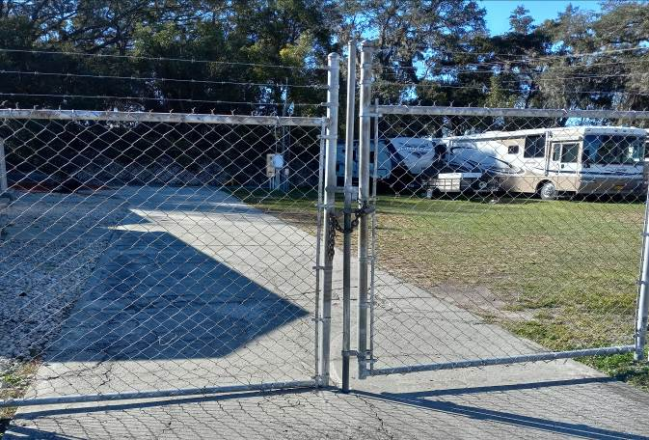

The keys for the RV / Boat Lot Area locks are provided to the Neighborhood Watch. 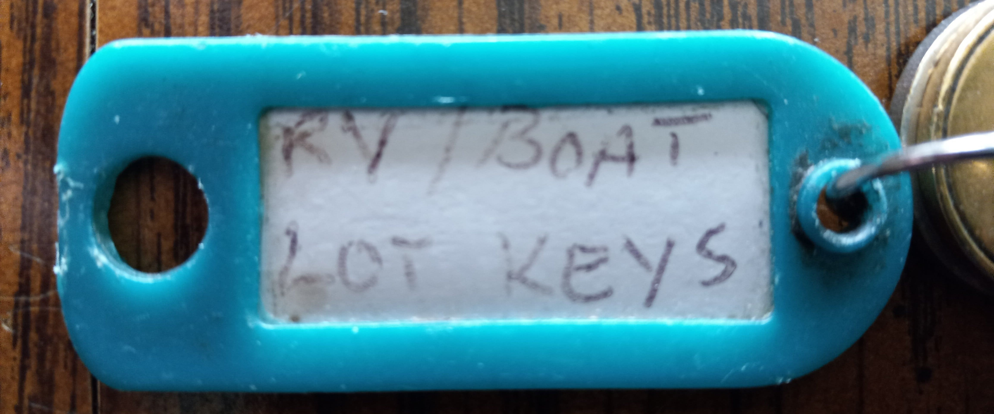

Check all the gates in the south rear perimeter fence. If one is found open report it immediately to the Neighborhood Watch Coordinator. Neighborhood Watch DOES NOT have keys for these locks.

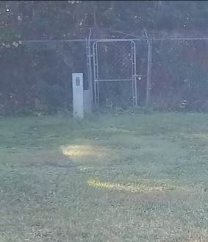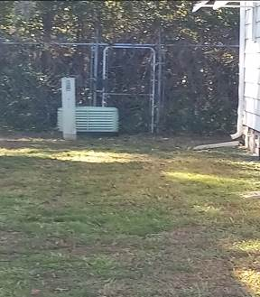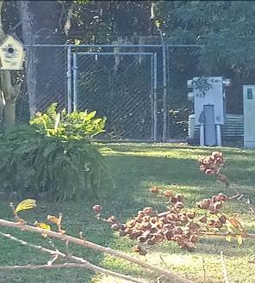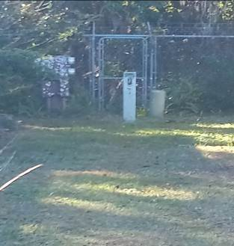

Note the pump house located at the east end of the Alligator Park. If the lights are flashing or an alarm is sounding, notify the Park Manager immediately.

If you encounter any persons walking in the park who seem confused or disoriented, please contact the Park Manager, and ask that they come deal with the situation. You may stay with the person, if its safe, until the Park Manager arrives.

MAIN AND SECONDARY PARK GATES

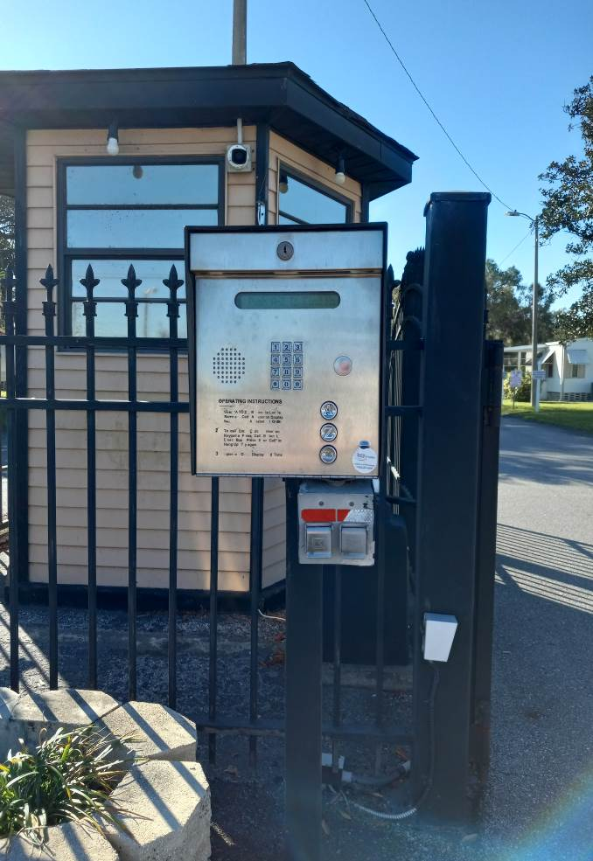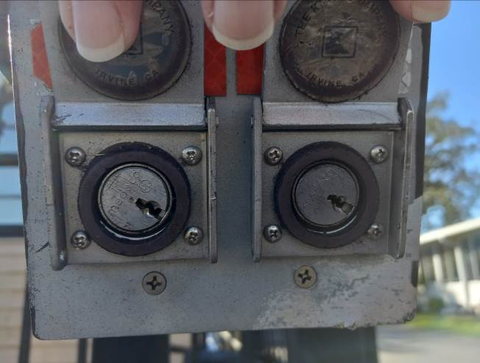
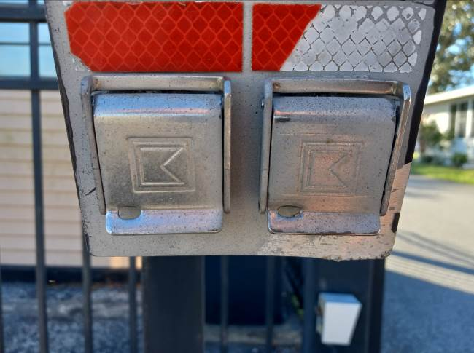

The main entry gate on Ariana St. has a keypad for code entry and two key slots used by Emergency Personnel to enter the part after 6:00PM. Both key slots should be in the position shown for normal operation. If the entrance gate is found open, check the slots to determine if an emergency is in progress. If the key slots are in the normal operating position yet the gates are open, a personal gate opener can be used to cycle the gate. If the gates still do not close, call the office after hours number, identify yourself, and ask them to notify the park manager to come reset the gate. Note the failure in the logbook and if possible, notify the Neighborhood Watch Coordinator the next day. If the exit gate is closed, it is not necessary to cycle the gate to test for normal operation.

If you find one of the key slots in another position, call the Lakeland Police Non-Emergency number and inquire if there is a call underway in the park, and ask if someone could be sent to reset the key position as we do not have access to these keys. Normal response time is less than 15 minutes

The east secondary gate should also be checked to ensure it’s closed to the point where humans can’t squeeze through. If the gate is found insecure, call the office after hours number, identify yourself, and notify them to have the park manager come and secure the gate.

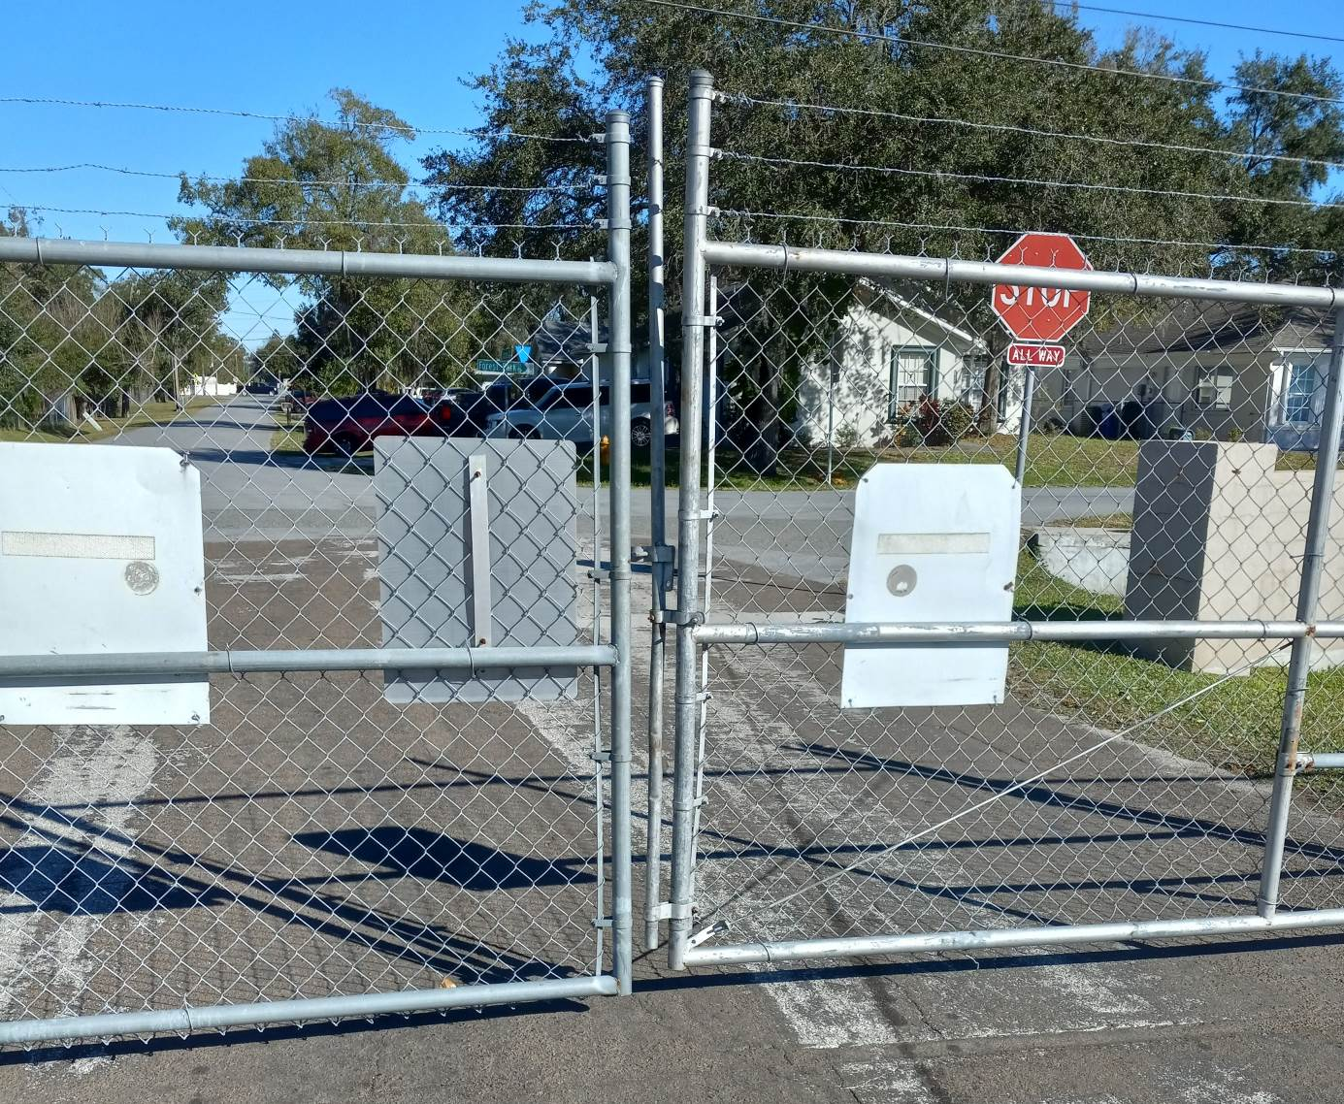

CLUBHOUSE LOCK UP

The North and South Clubhouses must be secured every night at some point during the patrol. At times, especially during the winter months when activities are more frequent, there may be people or groups still using the facilities later than 10:00PM. For special events, lock up of the used facility will be handled by either the event coordinator or the Neighborhood Watch Coordinator, while the scheduled volunteer will patrol the rest of the park as normal. For routine activities running late, inform the group that you will need to lock up by the end of your patrol, and give them time to vacate the building before returning. Ensure that the facility is locked by the end of the patrol.

North Clubhouse (NCC)

Only the exterior doors, the Manager’s Office door, and the copier room door of the NCC should be locked. All other interior doors should be left unlocked.

Check the bathrooms for anyone who may need medical assistance, overflowing or clogged toilets, running water, etc. Promptly call the office after hours number, identify yourself, and ask them to notify the park manager of the problem. If no problems are found, prop open the door and turn off the lights.

Inspect the kitchen area to ensure the stove and oven have been shut off, if not, turn them off and note the incident in the logbook. Check that the refrigerator and freezer are operating properly, if not, note the incident in the logbook and notify the Park Manager the next day. Check that there are no leaks or running water from the sink, if so, call the office after hours number, identify yourself, and ask them to notify the park manager of the issue.

The light switches are located near the North entrance door and the West entrance door. The sconce light switches are mounted below the sconce on both the East and West side walls. The bathroom lights are motion activated and will turn off automatically.

The North entrance door should be locked from the inside using the upper and lower latches on the right door, and the turn lock on the left side door.

The main East and West entrance doors have push bars that must be released in order for the doors to be locked. These doors require an 1/8” allen wrench to release push bar, which will then extend out about an inch. This should lock the doors from the outside and they should not be able to be opened from the inside without pressing the push bar in.

The Women’s and Men’s outside entrance doors have push bars that have to be released in order for the doors to be locked. These doors require a 5/32” allen wrench to release the push bar, which will then extend out about an inch. This should lock the doors from the outside and they should not be able to be opened from the inside without pressing the push bar in.

THE SOUTH CLUBHOUSE (SCC)

Inspect the kitchen area to ensure the stove and oven have been shut off, if not, turn them off and note the incident in the logbook. Check that the refrigerator and freezer are operating properly, if not, note the incident in the logbook and notify the Park Manager the next day. Check that there are no leaks or running water from the sink, if so, call the office after hours number, identify yourself, and ask them to notify the park manager of the issue.

Check the laundry room for running or leaking water from the machines, the sink, or the ice machine. Call the office after hours number, identify yourself, and ask them to notify the park manager of the issue. Lock the exterior door and turn off the lights.

Check the bathrooms for anyone who may need medical assistance, overflowing or clogged toilets, running water, etc. Promptly call the office after hours number, identify yourself, and ask them to notify the park manager of the problem. If no problems are found, prop open the door and turn off the lights.

Ensure the lights are off in the gym, check for any obvious damage to any of the exercise equipment and that the water cooler is not leaking. If there is running water, promptly call the office after hours number, identify yourself, and ask them to notify the park manager of the problem. Ensure that the door from the main room into the gym is secure and the dead bolt is engaged.

There is a small red flag mounted on the Handicapped Parking sign adjacent to the mailboxes. This flag is intended to inform residents when the mail has been delivered, and the Mail Man will put it in the UP position when his delivery is complete. Please move the flag to the DOWN position during lockup.
Flag Up Flag Down
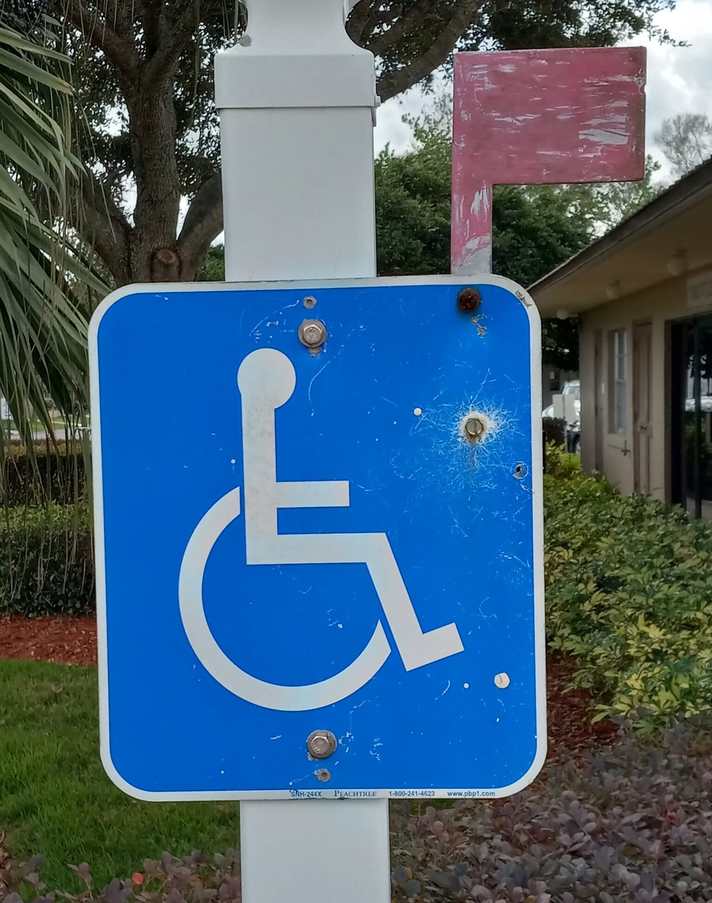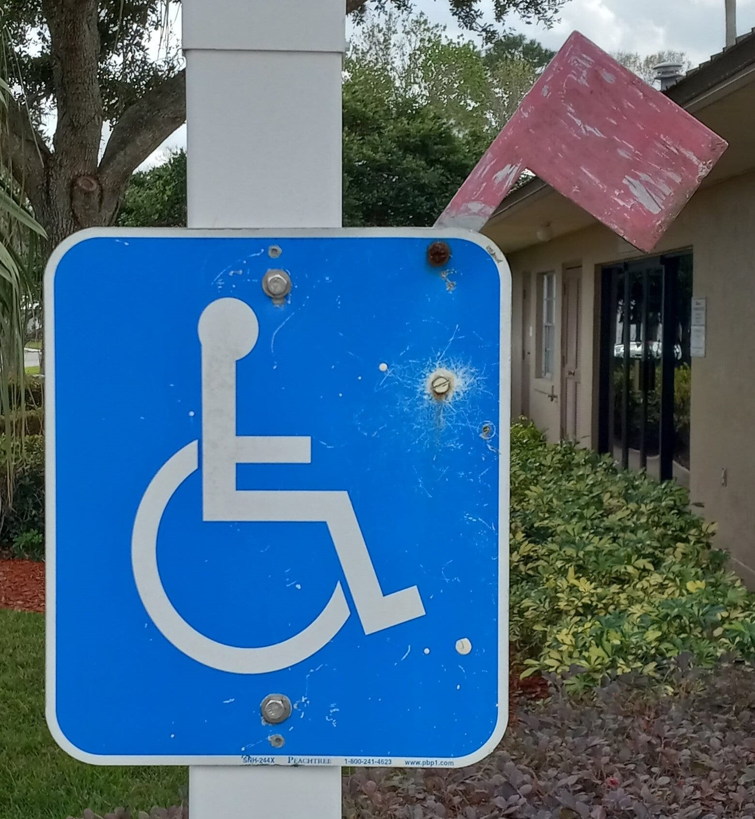

POOLS

Both the North and South pools need to be secured during the nightly patrol. Residents should be out of the pool by that time, but if not, notify them that you need to perform lock up and give them time to vacate the pool.

IF YOU MEET ANY RESISTANCE FROM RESIDENTS USING THE POOL WHEN ASKED TO LEAVE, IMMEDIATELY NOTIFY THE PARK MANAGER.

Ensure the umbrellas are all in the down position and are tied to prevent wind damage.

Observe and listen to the pump rooms for any unusual noise or leaking. Occasionally lights are left on by maintenance people and need not be reported. If problems are visible, promptly call the office after hours number, identify yourself, and ask them to notify the park manager of the problem.

Check the pools and the hot tub for any unusual debris.

There are three gates to lock at the South pool and one at the North pool. The lights at the North pool may be left on.

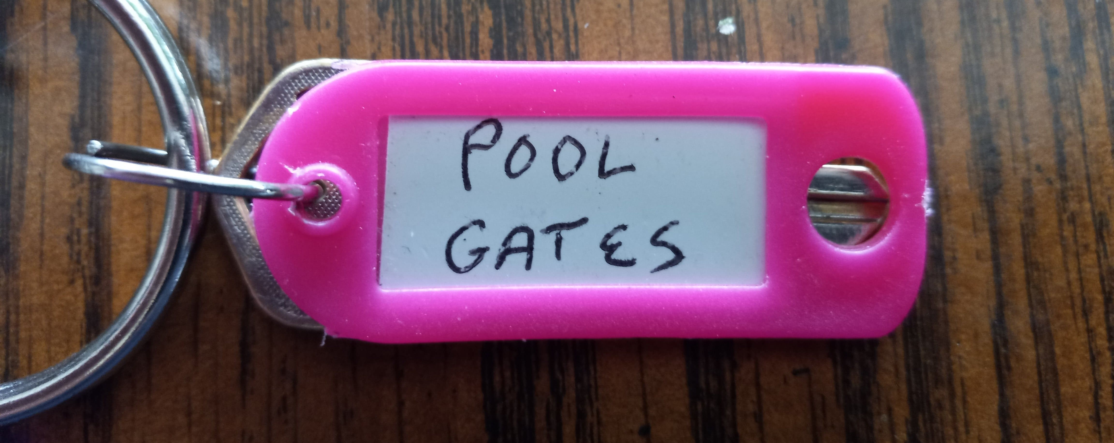

VERSION CONTROL

This manual was updated by the current Neighborhood Watch Coordinator and completed in February 2023.

This version, 2.3 supersedes the previous manual published by Rick Galarneau in June 2021 and supersedes any and all version previous to that. This version will be updated to remain current by the Neighborhood Watch Coordinator.

The most current version of the Neighborhood Watch Patrol Manual will always be available in the Neighborhood Watch Cart and will be used as the basis for all volunteer training.

The residents here in Woodbrook Estates are very grateful for your service to the Neighborhood Watch program, and your diligence in providing the tasks that need to be done. Please stay safe, keep your friends and neighbors safe, and continue to make the park a safer place for us all.

Take care,

Bruce Cray
Neighborhood Watch Coordinator
LOT 247
503 984 2373

Ver 1.0 Rick Galarneau June 2021
Ver 2.0 Bruce Cray January 2023 – Manual Revised
Ver 2.1 Bruce Cray January 2023 – Inserted Photos
Ver 2.2 Bruce Cray January 2023 – Compressed photos
Ver 2.3 Bruce Cray March 2023 – Added photos for clarity
Ver 2.4 Bruce Cray Nov 2023 – Revised instructions for new NCC doors

